Steps to install DBATools in Windows 7 Operating System.
1. Open PowerShell with "Run as Administrator".
2. Execute below script in powershell window. (or) You can download it from below links.
https://github.com/RichieBzzzt/dbatoolsdebug/blob/master/install.ps1
https://raw.githubusercontent.com/RichieBzzzt/dbatoolsdebug/master/install.ps1
3. Post installation, Type following command in powershell window.
Get-Command
This would list out all powershell modules which got installed related to SQL Server Adminstration.
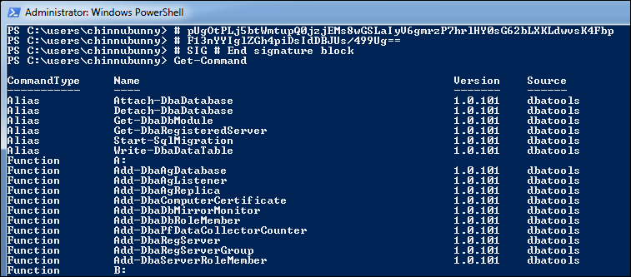

Reference sites for DBA Activities using DBATools Powershell modules:
https://dbatools.io/getting-started/
https://www.sqlshack.com/dbatools-powershell-module-for-sql-server/
Prepared by Praveen Madupu (Sr SQL DBA)
Mb: +91-9866130093 Mail: praveensqldba12@gmail.com

